|  |  |
| --- | --- |
| GEN AI LEARNING  **Complete Generative AI Learning – New Year Challenge** | WRITTEN BY: ALOY |

***Day – 9***

**Enhancing Structured Output and Abstraction for Specific Data Fields in LLM Integration**

The ability to generate structured output from a Language Learning Model (LLM) in alignment with predefined data structures is critical when relying on its outputs for downstream applications. Ensuring that the generated responses adhere to specific constraints improves accuracy and enhances the system's reliability.

Beyond structured output, an additional abstraction layer is often required for fields with specific, predefined options. These fields, such as dropdown menus in user interfaces, must constrain their values to a predetermined set of choices. Integrating this level of specificity demands modifications to the codebase, ensuring that the output aligns with the allowable values.

For example, consider a schema with a field labeled "Hair Color." The permissible values for this field are strictly limited to ["grey", "black", "white"]. If an LLM generates a value outside this set, the system should default to selecting "unknown" as a fallback. This approach ensures the integrity of the data while maintaining flexibility in the face of unexpected or unsupported outputs.

Below is the implementation demonstrating how this is achieved in code:

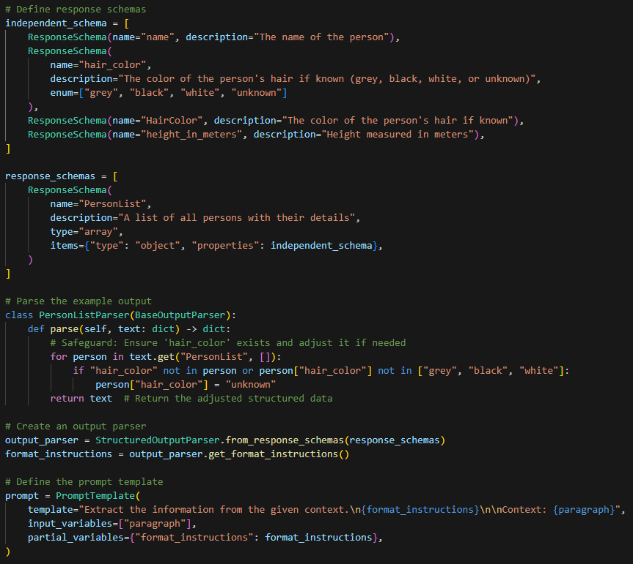

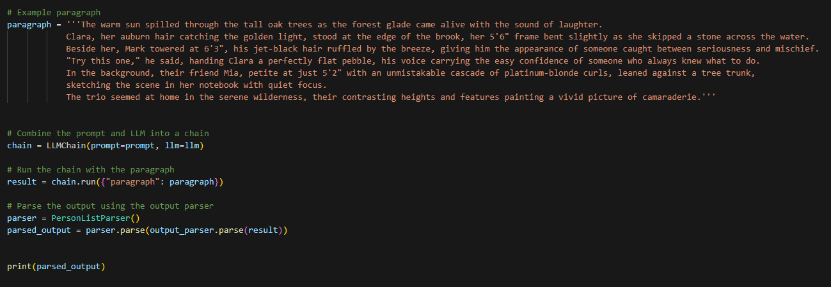

**Output**:

{'PersonList': [{'Name': 'Clara', 'Height': '5\'6"', 'HairColor': 'Auburn', 'hairColor': 'unknown'}, {'Name': 'Mark', 'Height': '6\'3"', 'HairColor': 'Jet-Black', 'hairColor': 'unknown'}, {'Name': 'Mia', 'Height': '5\'2"', 'HairColor': 'Platinum-Blonde', 'hairColor': 'unknown'}]}

Actual value extracted is highlighted as HairColor whereas hairColor is the field modified as per option field value where only ["grey", "black", "white"] options can be selected.